A PROJECT REPORT
ON
AI-Enhanced Decentralized Identity Verification System
Submitted by
Akshay Gojiya (22IT452)
For Partial Fulfillment of the Requirements for Bachelor of Technology in
Information Technology

Guided by
Dr. Keyur N. Bhrambhatt, IT Department BVM
Brijesh Patadiya, Devx AI Labs
May, 2026

Information Technology Department
Birla Vishvakarma Mahavidyalaya Engineering College
(An Autonomous Institution)
Vallabh Vidyanagar – 388120
Gujarat, INDIA

 | Birla Vishvakarma Mahavidyalaya Engineering College  (An Autonomous Institution)  Information Technology Department  AY: 2025-26, Semester II

CERTIFICATE

This is to certify that the project work entitled AI-Enhanced Decentralized Identity Verification System has been successfully carried out by Akshay Gojiya (22IT452) for the subject Major Project (4IT33) during the academic year 2025-26, Semester-VIII for partial fulfilment of Bachelor of Technology in Information Technology. The work carried out during the semester is satisfactory.

Dr. Keyur Brahmbhatt  Head, IT Department  BVM | Brijesh Patadiya  Devx Ai Labs

Certificate of Completion
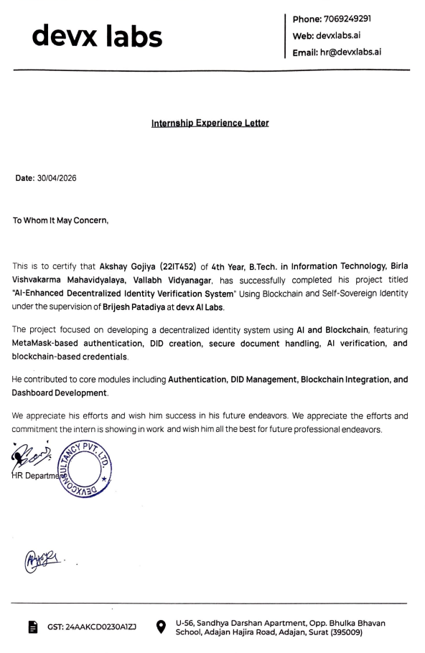

Acknowledgement

I would like to express my sincere gratitude and deep appreciation to my respected faculty guide for their invaluable guidance, continuous support, and constructive suggestions throughout the development of this project. Their expertise, encouragement, and timely feedback have played a crucial role in shaping this work and ensuring its successful completion.

I am also thankful to the team at Devx AI Labs for providing me with the opportunity to work on this project as part of my internship. Their technical insights, industry exposure, and constant mentorship greatly contributed to enhancing my understanding of real-world system design, blockchain integration, and modern software development practices.

I extend my heartfelt thanks to the Head of the Information Technology Department and all the faculty members of BVM Engineering College for providing the necessary academic support, infrastructure, and learning environment required to carry out this project effectively.

I would also like to acknowledge the contribution of open-source communities and documentation resources, which provided valuable references and technical support during the implementation of various modules in this project.

Finally, I express my gratitude to the institution for giving me the platform to apply theoretical knowledge into practical implementation, thereby enhancing my technical and problem-solving skills.

Abstract

The AI-Enhanced Decentralized Identity Verification System is designed to provide a secure, privacy-preserving, and user-controlled digital identity solution. Traditional identity verification systems rely on centralized databases, making them vulnerable to data breaches and misuse of sensitive information. This project addresses these challenges by leveraging blockchain technology, artificial intelligence, and decentralized storage.

The system enables users to create a Decentralized Identifier (DID) linked to their blockchain wallet, eliminating the need for traditional password-based authentication. Identity verification is enhanced using AI techniques such as face recognition, liveness detection, and OCR-based document validation. Verified credentials are securely stored as hashes on the blockchain, ensuring immutability and trust.

Additionally, the system supports selective disclosure of identity attributes using QR codes, allowing users to share only the required information while maintaining privacy. The architecture integrates modern technologies including Next.js, Node.js, MongoDB, Ethereum blockchain, and IPFS.

Overall, the system provides a scalable, secure, and efficient approach to digital identity management, reducing dependency on centralized authorities and empowering users with full control over their identity data.

List of Figures

Figure No. | Title | Page
Figure 3.1 | Project Timeline Chart | 9
Figure 3.2 | Use Case Diagram | 14
Figure 3.3 | Data Flow Diagram Level 0 | 15
Figure 3.4 | Data Flow Diagram Level 1 | 15
Figure 3.5 | Class Diagram | 16
Figure 3.6 | Entity Relationship Diagram | 17
Figure 3.7 | Sequence Diagram | 18
Figure 3.8 | State / Activity Diagram | 19
Figure 4.1 | Landing Page Interface | 23
Figure 4.2 | Identity Verification Workflow Screen | 23
Figure 4.3 | User Dashboard Interface | 24
Figure 4.4 | Credential Management Interface | 24
Figure 4.5 | Admin Dashboard Interface | 25
Figure 4.6 | Verification Review Interface | 25

List of Tables

Table No. | Title | Page
Table 3.1 | Comparative Analysis of Existing Systems | 8
Table 3.2 | User Collection Data Dictionary | 20
Table 3.3 | Document Collection Data Dictionary | 20
Table 3.4 | Verification Collection Data Dictionary | 20
Table 3.5 | Credential Collection Data Dictionary | 21
Table 3.6 | DID Registry Contract Structure | 21
Table 3.7 | Credential Registry Contract Structure | 22
Table 4.1 | Test Cases for Authentication & Wallet Integration | 26
Table 4.2 | Test Cases for DID Management | 27
Table 4.3 | Test Cases for Document Management | 27
Table 4.4 | Test Cases for AI-Powered Verification | 27
Table 4.5 | Test Cases for Credential Management | 28
Table 4.6 | Test Cases for Selective Disclosure & QR Module | 28
Table 4.7 | Test Cases for Blockchain Integration | 28
Table 4.8 | Test Cases for User Dashboard Module | 28
Table 4.9 | Test Cases for Admin Module | 29

List of Abbreviations
Abbreviation | Meaning
DID | Decentralized Identifier
SSI | Self-Sovereign Identity
VC | Verifiable Credential
ZKP | Zero-Knowledge Proof
IPFS | InterPlanetary File System
KYC | Know Your Customer
OCR | Optical Character Recognition
AI | Artificial Intelligence
ML | Machine Learning
DID Registry | Smart Contract for managing DIDs
Credential Registry | Smart Contract for storing credential hashes

Table of Content
Chapter 1: Introduction 1
1.1 Brief Overview of the Work 1
1.2 Objective 1
1.3 Scope 2
1.4 Project Modules 3
1.5 Project Hardware/Software Requirements 4
Chapter 2: Literature Review 6
2.1 Decentralized Identifiers and Self-Sovereign Identity 6
2.2 Blockchain-Based Digital Identity Management 6
2.3 Verifiable Credentials for Secure Identity Sharing 6
2.4 Biometric Authentication and Liveness Detection 7
Chapter 3: System Analysis and Design 8
3.1 Comparison of Existing Applications with Proposed System 8
3.2 Project Feasibility Study 9
3.2.1 Technical Feasibility 9
3.2.2 Operational Feasibility 9
3.2.3 Economic Feasibility 9
3.3 Project Timeline Chart 9
3.4 Detailed Modules Description 10
3.5 Project SRS 14
3.5.1 Use Case Diagram 14
3.5.2 Data Flow Diagrams 15
3.5.3 Class Diagram 16
3.5.4 Entity Relationship Diagram 17
3.5.5 Sequence Diagram 18
3.5.6 State / Activity Diagram 19
3.6 Data Dictionary 20
Chapter 4: Implementation and Testing 23
4.1 User Interface and Snapshot 23
4.2 Result Analysis 26
4.3 Testing using Use Cases 26
4.3.1 Authentication & Wallet Integration Module 26
4.3.2 DID Management Module 27
4.3.3 Document Management Module 27
4.3.4 AI-Powered Verification Module 27
4.3.5 Credential Management Module 28
4.3.6 Selective Disclosure & QR Module 28
4.3.7 Blockchain Integration Module 28
4.3.8 User Dashboard Module 28
4.3.9 Admin Module 29
Chapter 5: Conclusion and Future Work 30
5.1 Conclusion 30
5.2 Future Work 30
Chapter 6: References 32

